Open-Source Frameworks Research

1. Introduction
Open-source frameworks play a critical role in enabling affordable, scalable, and transparent AI-driven IoT systems for hydroponic farming. By leveraging established libraries and cloud services, developers can focus on system integration and optimization rather than building tools from scratch. This document explores three major categories of open-source and widely adopted frameworks relevant to hydroponic water quality monitoring: machine learning libraries (scikit-learn), edge AI frameworks (TensorFlow Lite), and cloud IoT platforms and services.

2. scikit-learn for Classical Machine Learning

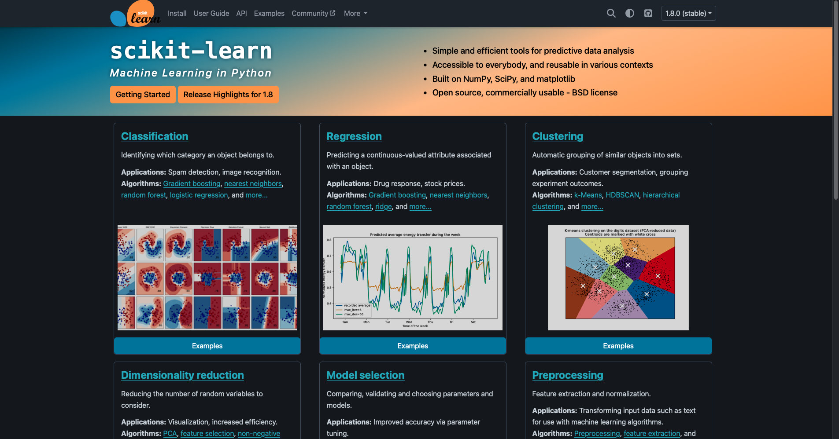

2.1 Overview
scikit-learn is a widely used open-source machine learning library in Python that provides efficient implementations of classical ML algorithms. It also provides various tools for model fitting, data preprocessing, model selection, model evaluation, and many other utilities. It is particularly well-suited for structured, tabular, and time-series-derived data such as hydroponic sensor readings.

2.2 Relevant Capabilities
scikit-learn supports a broad range of algorithms applicable to hydroponic monitoring:
- Regression models (Linear Regression, Ridge, Lasso, Random Forest Regressor)
- Classification models (Logistic Regression, Support Vector Machines)
- Anomaly detection (Isolation Forest, One-Class SVM)
- Preprocessing utilities (scaling, normalization, imputation)

2.3 Application in Hydroponics
In a hydroponic context, scikit-learn can be used to:
- Predict short-term trends in EC or pH based on historical sensor data
- Detect abnormal water quality patterns using unsupervised anomaly detection
- Establish interpretable baseline models to understand feature importance
Because scikit-learn models are relatively lightweight and interpretable, they are well-suited for experimentation, benchmarking, and cloud-based inference.

2.4 Advantages and Limitations
Advantages:
- Easy to use and well-documented
- Strong support for preprocessing and evaluation
- Highly interpretable models
Limitations:
- Limited support for deep learning and long sequential dependencies
- Typically requires cloud or local server execution rather than microcontroller deployment

3. TensorFlow Lite for Edge AI

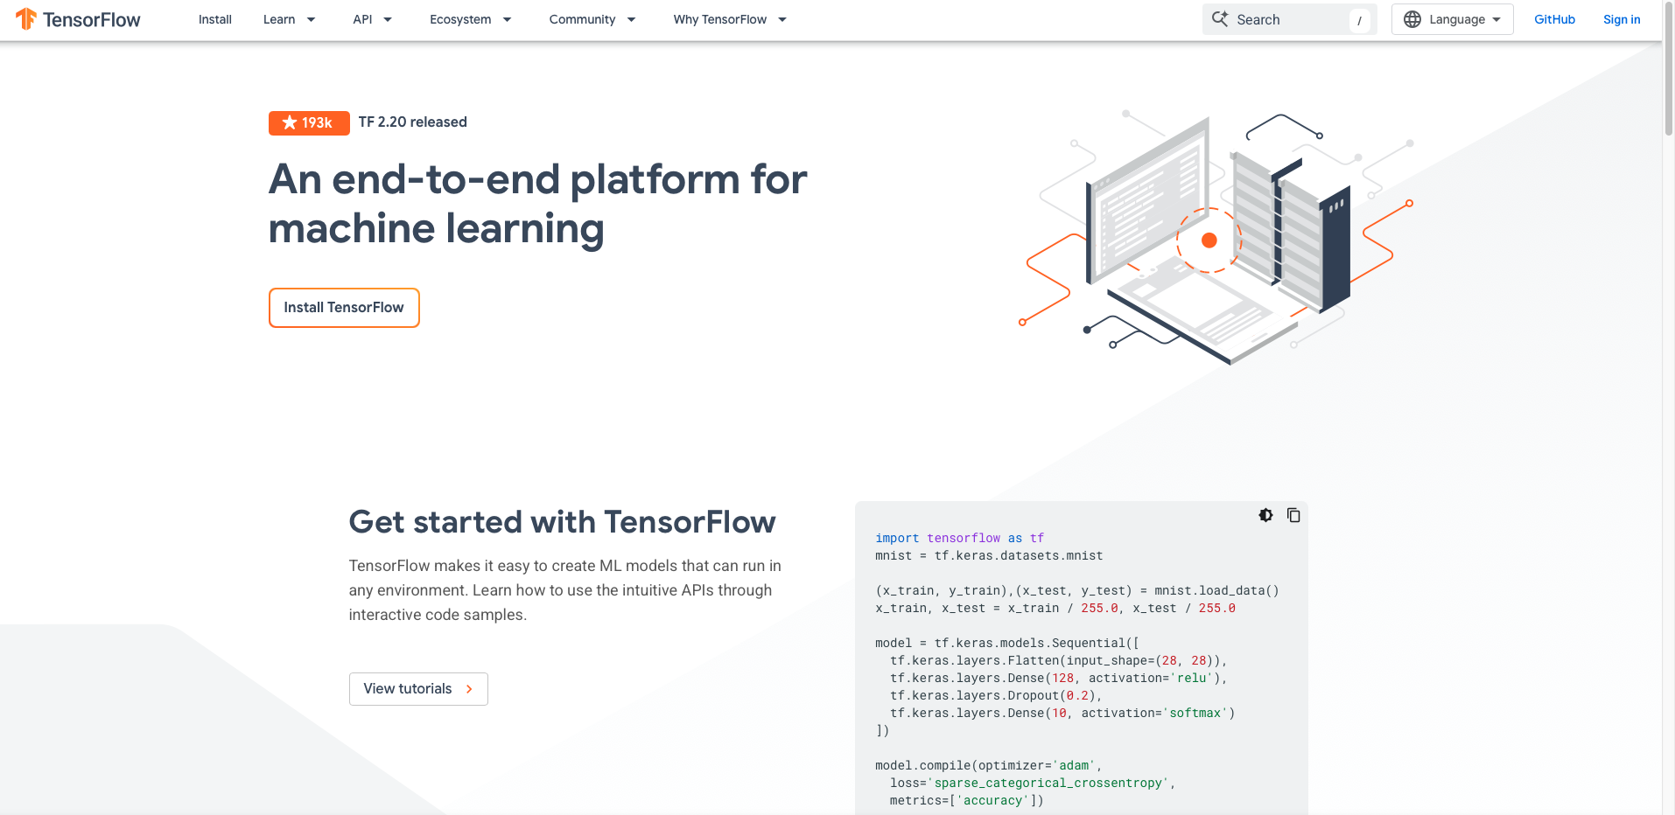

3.1 Overview
TensorFlow Lite (TFLite) is a lightweight version of TensorFlow designed for deploying machine learning models on resource-constrained devices such as microcontrollers, edge gateways, and mobile devices.

3.2 Key Features
- Optimized model formats for low memory and low latency
- Support for quantized models (e.g., int8)
- Compatibility with microcontrollers and embedded Linux systems
- Integration with TensorFlow ecosystem

3.3 Application in Hydroponics
TensorFlow Lite enables edge inference in hydroponic systems, allowing predictive models to run close to the sensors. Typical use cases include:
- Short horizon forecasting of pH or EC directly on an edge device
- Real-time anomaly detection without cloud dependency
- Faster response to critical events such as pump failure or nutrient overdosing
Edge deployment reduces latency and reliance on continuous internet connectivity, which is particularly valuable in greenhouse or indoor farming environments.

3.4 Advantages and Limitations
Advantages:
- Low-latency inference
- Reduced cloud costs and bandwidth usage
- Improved resilience to network outages
Limitations:
- More complex deployment pipeline
- Limited model size and complexity
- Training typically performed off device

4. Cloud IoT Services and Platforms

4.1 Overview
Cloud IoT services provide scalable infrastructure for data ingestion, storage, analytics, and visualization. While not always fully open-source, many platforms integrate open standards and open-source tools.

4.2 Commonly Used Services
Typical cloud components in an IoT hydroponic system include:
- MQTT brokers (e.g., Eclipse Mosquitto)
- Time-series databases (InfluxDB, TimescaleDB)
- Data processing pipelines (Node-RED, Apache Kafka)
- Visualization tools (Grafana)

4.3 Application in Hydroponics
Cloud services support:
- Centralized storage of high-frequency sensor data
- Long-term trend analysis and historical comparisons
- Cloud-based model training and evaluation
- Remote monitoring via dashboards and alerts
These platforms enable scalability from small experimental setups to larger multi-unit hydroponic farms.

4.4 Advantages and Limitations
Advantages:
- High scalability and reliability
- Centralized monitoring and analytics
- Integration with dashboards and alerting systems
Limitations:
- Dependence on network connectivity
- Potential data privacy concerns
- Ongoing operational costs

5. Comparative Summary
Framework | Primary Role | Best Use Case | Deployment Context
scikit-learn | Classical ML | Forecasting, anomaly detection, baselines | Cloud / local server
TensorFlow Lite | Edge AI inference | Low-latency predictions, resilience | Edge devices
Cloud IoT Services | Data infrastructure | Storage, visualization, training | Cloud

6. Relevance to This Research
In this research, scikit-learn provides interpretable baseline models for forecasting and anomaly detection, TensorFlow Lite enables future edge deployment of predictive models, and cloud IoT services support data ingestion, storage, visualization, and model training. Together, these frameworks form a flexible and scalable foundation for AI-driven hydroponic water quality monitoring.
Their combined use allows the system to balance accuracy, interpretability, latency, and resource constraints while maintaining affordability and extensibility.

